**Forum:** General Assembly

**Issue:** Developing strategies to bridge the education gaps caused by the Covid 19 pandemic

**Student Officer:** Benediktus X. Ries

**Position:** Chair of the General Assembly

Introduction

During the Covid-19 pandemic, schools all over the world shut down for months, and even years, at a time. This obstruction to the standard method of education has spawned large gaps in reading, writing, and math in the pandemic era generation compared to previous generations. Furthermore, social gaps in learning have further deteriorated. Those who struggled to access education in the best times struggled even most during the pandemic due to the shutdown of in person education, the pandemic related decline in wealth, and myriad other pandemic related issues. Bridging the gaps in both practical education as well as access to such education will be crucial to ensure future generations have the knowledge, thinking skills, and equality to take the reigns of the world left to them.

Definition of Key Terms

**Develop**

In this scenario to develop means to grow or expand a concept into a more elaborate or widespread version of itself. This may be self-evident but recall the General Assembly deals with broad recommendations to member states, not hyper specific outlines. Ensure all clauses and resolutions *develop* and not *impose.* “Impose” suggests forcing Member States to follow these recommendations.

**Strategies**

Strategies, in terms of education, are a long-term outline of visions and goals for student success and improvement. All strategies should be developed with the final goal of reducing the deficit in student learning caused by COVID-19 and its confounding factors.

**Education Gaps**

Education gaps are the noticeable decline in educational scores in students during and post the COVID-19 pandemic. The goal of this committee will be to provide recommendations to member states to close this gap, and bring students back to the levels, and eventually above, their pre-COVID peers.

General Overview

In 2020, a pandemic shut down schools nearly globally. Students everywhere stopped attending school in person in the name of public health. Students homeschooled, participated in online school, or, in some cases, stopped completing schoolwork all together. The difficulty of the time, as well as tracking student learning while distanced, caused many to fall behind in their learning. While this was not unexpected, the failure of schools to advance in their learning post-COVID has been troubling. Educational institutions’ inability to close these gaps in student learning has been confounded by various social and global issues such as but not limited to poverty, unequal access, racism, and sexism.

Statistical understanding

Global test scores have dropped drastically, with little sign of improvement. Member states of the Organization for Economic Co-operation and Development (OECD) and 44 partner countries conduct a yearly test to assess students learning in Math and Reading. On average, for all nations taking part in the test, Math fell by *15 points* and reading by *10*. 20 points is considered a year of learning. This means in a total of 77 nations, students are behind, on average, by nearly a whole grade in math and half a grade in reading. Some nations saw jaw-dropping declines. The Netherlands, Iceland, and Germany all saw drops as large as *25 points in math*. Albania saw a *69 point decrease* and Jordan 39 points. This issue is of global important and of global effect. It seems all nations, regardless of development or income, are experiencing extremely concerning declines and stagnation.

Demographic understanding

While all nations are experiencing some decrease in their testing scores, the most affected are developing nations. Developing nations had lower scores pre-pandemic and experienced the sharpest decline after. Poverty, unequal access, and little available money to invest into public education has presented a massive issue for these nations. High educational scores are strongly correlated with higher incomes and growth, meaning lower scores for these nations puts into jeopardy their future. Moreover, minority demographics in developed nations faced similar perils. There is a clear schism in education which existed pre-COVID19 and has grown since.

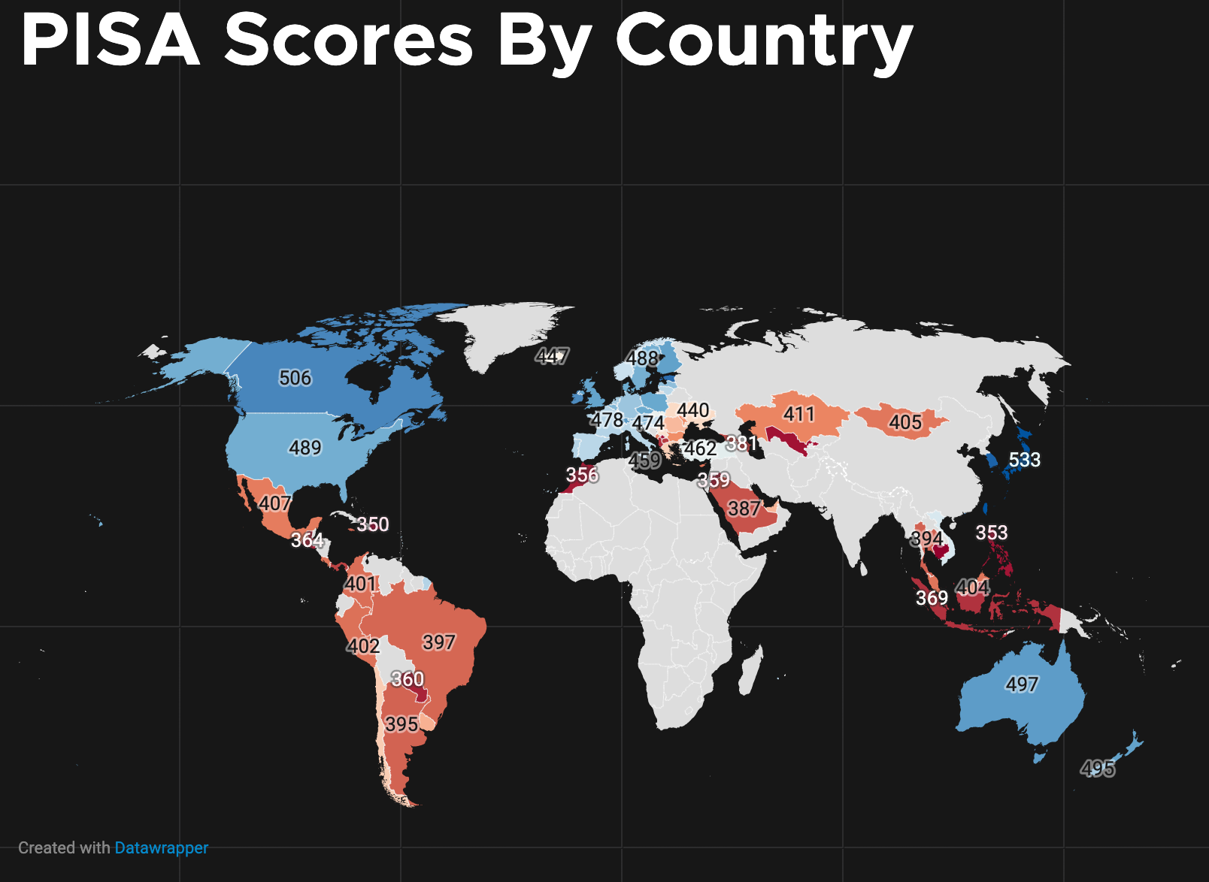

*Map showing scores from the Program for International Student Assessment in 2022.*

Major Parties Involved

(United Nations Educational, Scientific, and Cultural Organization (UNESCO))

UNESCO is the United Nations (UN) agency responsible for global educational standards and goals. They work with over 300 non-governmental organizations (NGOs), have 53 field offices, and 199 national commissions. They are the center for global education. Through UNESCO, funding and support can be guided and directed to choice organizations which can make meaningful impact. UNESCO focuses on the education of the students of its member states and plays a critical role in ensuring quality education globally.

(Educational Institutions)

Those which educate students hold unequivocal power in how they aid students in closing the educational gaps. It is crucial that these educational institutions take this problem of global importance serious and work hard with each other, their students, governments, and NGOs. Educational Institutions will be the disseminators and main points of contact of nearly all funding and programs aimed to help students. Educational Institutions are where students are suffering, and they will be where students will prosper.

(Governments)

Governments often carry the responsibility of deciding educational programs, funding, and standards. Without the support of governments, nothing can be done. Governments also carry the role of ensuring a future for their nation, a future education provides. Governments typically want well educated citizens. Without well-educated citizens, governments cannot guarantee a prosperous future for themselves. Unfortunately, building this future is often not a matter of will, but ability. Education provides higher paying jobs, more advanced economic sectors, and overall increased opportunity and happiness among citizens. The future of nations is found in education.

(Students)

Students are the absolute main stakeholder in this situation. It is easy to become dissociated when discussing such abstract topics, but these are the students whose futures are at stake. For the first time in decades, there is a real chance the upcoming generation will be drastically less educated than their predecessors. These are the students who will have lower chances of economic success, access to higher education, and overall happiness due to the failures of their governments and schools.

UN Involvement, Relevant Resolutions, Treaties and Events

The UN has been heavily involved in ensuring quality education globally since its founding. Both the UN Universal Declaration of Human Rights (UDHR) and the Convention on the Rights of a Child both guarantee access to education as a human right. UNESCO partners with every nation and nearly every educational program (i.e. the International Baccalaureate) to ensure access to quality education is the right of every human, not only the privileged. The UN Security Council (UNSC) passed resolution 2601 which implemented measures to ensure the protection of education in times of conflicts. The general assembly has passed myriad resolutions in its history calling for and reminding nations the importance of education. The UN is and has been involved in education for decades, and education is considered a pivotal building block of a unified world.

Timeline of Events

|  |  |
| --- | --- |
| **Date** | **Description of event** |
| 1917  1945  December 10, 1948 | Standardized tests gain popularity and are implemented globally.  With the outbreak of the cold war, education is more than ever a matter of political and geopolitical importance as a means of enforcing an ideology and out competing a rival.  UDHR passed by the UN guaranteeing education as a global human right. |
| May 17 1954 | Brown v. Board of Education, segregation on the basis of race declared unconstitutional in the US, a major step to achieving the dreams of the UDHR. |
| 1983  2001  2020  2020-2024 | A Nation at Risk Report, a call to action by the US government to improve the quality of education provided in the country. A good example of how these issues have been dealt with in the past.  The infamous ‘No Child Left Behind’ policy. An example of policies which may be enacted, and how such policies can have drastic effects on the expectations of schools and students, as well as government involvement in schooling.  The COVID-19 Pandemic thrusts the world into years of online learning and economic peril. Students all over the world begin distance and online learning, while both schools and pupils struggle to cope with the stresses and difficulties presented to them.  Test scores have declined and stagnated globally, despite the widespread return to traditional school. This presents an additional stressor to schools and students as they must now catch-up on old material, in some instances as much as a whole grade level’s worth, while also learning the material designated for their present. |

Previous Attempts to Resolve the Issue

While test scores have seldom seen such global decline, nations all over the world have seen local decline in their history. Throughout many nations’ history, there has been various educational initiatives to either modernize, reformat, or otherwise make improvements to the education system. Mentioned on the timeline above are two of the most famous initiatives, A Nation at Risk and No Child Left Behind. Such initiatives refocus an educational system’s attention to certain demographics or types of students, such as ensuring impoverished or underserved communities are guaranteed access to quality education or designing the curriculum to better support lower performing students as opposed to higher performing ones. Every nation has at some point launched educational initiatives, and it is important to understand what these initiatives have looked like, do look like, or will like for your nation as to understand where priorities lie.

Possible Solutions

There are myriad solutions to every problem, the ones prescribed below are historic solutions which have proven results. Do not feel confined by these solutions but do take them as inspiration or a springboard for brainstorming.

1. Reenforce the importance of education: Since 2020, the entire globe has seen crisis after crisis in ways which have not been witnessed since the Cold War. It is easy for domestic policies such as education fall to the sidelines as more dire and pressing international or domestic issues take prevalence. While education is not always necessarily the most important short-term policy, it is one of the most important long-term ones, as it will shape the type of citizens a nation has for the next generation. Provide pathways to success for nations and remind them how crucial all education, but especially basic, is for the future. Emphasize how imperative it is for curiosity, critical thinking, and situational awareness are for basic success and growth for a person and a nation.
2. Ensure a rising tide which lifts all boats: This famous expression essentially means improved environments, improve all aspects of that environment. Better trained teachers, better designed curriculums, and better funded systems often see vast improvements in student success. Declining standards of learning is a crisis. It must be treated as one. Government must build better school environments and take a purposeful methodical approach to this issue, as they would with any other crisis. Calling attention to this crisis and recommending solutions to improving the dire circumstances of many school systems will help to tackle the underlying problem of this crisis, which is underfunded, undertrained, and seemingly unimportant educational systems.
3. Recommend a bottom-up approach to learning and tackling underlying issues: While it is crucial all students can realize their full potential, ensure all students are able to meet a basic standard. Focusing on only those deemed ‘gifted’ will inevitably leave the vast majority of a student population behind. Having a few top students, while everyone else lags behind, is not a sustainable way of building a future in which *everyone* is sufficiently educated.
4. Remedial Classes: Students with learning gaps might be provided with additional classes after school or during summer holidays, with an emphasis on reading and maths. This would cost money, which richer countries would be in a better position to find than poor countries.
5. More Educators: Because Covid learning gaps are uneven, with students from poor families falling far more behind than students from wealthy families, teachers are having to deal with a much broader range of abilities in their classrooms. Having more teachers or learning support aids would make it easier to cope with the differing needs of students. This would cost money, which richer countries would be in a better position to find than poor countries.
6. Repeating Grades: If students have not mastered basic reading and maths, advancing them into a higher grade where they will be expected to handle more complex reading and maths for which they lack the foundation can be counterproductive. Instead of automatically advancing all students to the next grade level at the end of each school year, students could be held back until they reach grade level. This practice is controversial as the social emotional effects of holding some children back while their friends advance to the next grade can counteract any learning benefits. There is some evidence to suggest that retaining students in primary school while basic reading skills are still being taught is more beneficial than holding older students back a grade. It also means that countries have to find the money to fund the held-back students for an extra year of public education. In Kenya during Covid, the government simply closed all the public schools and had the whole country repeat the grade the next year.

Research Guide

To continue research on this topic, use key terms such as:

1. Educational gaps/decline
2. Math and reading scores
3. COVID-19

For historic background/understanding keep in mind some nations may have had different names or been a part of another nation. Furthermore, remember political sects and alliances *often*, but not always, have similar views and goals, so research may be done indirectly through researching a political sects view on the topic.

Also keep in mind, some nations and regions will have specific, and differing, goals and requirements. Ensure you understand your nation’s view on the issues mentioned above as well as other social and global topics, as these may help inform you further.

Some of the videos below may explain some of the topics mentioned above in a more succinct, specific, and understandable format:

1. Gaps in education in income class: [Achievement Gaps](https://www.youtube.com/watch?v=7iOjDdgVrG8)
2. Global Inequality in Education: ["Passport to the future"](https://www.youtube.com/watch?v=T-JVpKku5SI)
3. How Real-World Educators are Dealing with Test Score Decline: ["Prepared for Success"](https://www.youtube.com/watch?v=IS2wiLdgksU)

If you have trouble understanding anything you find on the internet, a great tool you can use is <https://beta.diffit.me/#url>. Just paste the URL of the article you have trouble with into the app and it will convert it to a simpler reading level.

Bibliography

Binkley, Collin, and The Associated Press. “School Children Around the World Saw an ‘Unprecedented Drop in Performance’ during the Pandemic, Global Study Finds.” *Fortune*, Fortune, 5 Dec. 2023, fortune.com/2023/12/05/pandemic-learning-loss-how-bad-math-scores-unprecedented-drop/. Accessed 16 Jan. 2024.

Doan-Nguyen, Ryan. “Post-COVID Learning Losses.” *Harvard Magazine*, 17 July 2023, www.harvardmagazine.com/2023/07/kane-covid-learning-losses#:~:text=Math%2C%20reading%2C%20and%20history%20scores,of%20a%20year%20in%20reading. Accessed 16 Jan. 2024.

Di Pietro, Giorgio. “The Impact of Covid-19 on Student Achievement: Evidence from a Recent Meta-Analysis.” *Educational Research Review*, vol. 39, Elsevier BV, May 2023, pp. 100530–30, https://doi.org/10.1016/j.edurev.2023.100530. Accessed 16 Jan. 2024.

Dorn, Emma, et al. “COVID-19 and Education: An Emerging K-Shaped Recovery.” *McKinsey & Company*, McKinsey & Company, 14 Dec. 2021, www.mckinsey.com/industries/education/our-insights/covid-19-and-education-an-emerging-k-shaped-recovery. Accessed 16 Jan. 2024.

“Education Transforms Lives.” *Unesco.org*, 2022, www.unesco.org/en/education. Accessed 16 Jan. 2024.

Fomba, Benjamin Kamga et al. “Institutional Quality and Education Quality in Developing Countries: Effects and Transmission Channels.” *Journal of the Knowledge Economy*, vol. 14, no. 1, Springer Science+Business Media, Jan. 2022, pp. 86–115, https://doi.org/10.1007/s13132-021-00869-9. Accessed 16 Jan. 2024.

Friedell, Dan and the Associated Press. “Math, Reading Test Scores in US Continue to Drop after Pandemic.” *Voice of America*, VOA - Voice of America English News, 24 June 2023, learningenglish.voanews.com/a/math-reading-test-scores-continue-to-drop-after-pandemic/7148954.html. Accessed 16 Jan. 2024.

Halloran, Clare, et al. *Post COVID-19 Test Score Recovery: Initial Evidence from State Testing Data*. Apr. 2023, [https://doi.org/10.3386/w31113. Accessed 16 Jan. 2024](https://doi.org/10.3386/w31113.%20Accessed%2016%20Jan.%202024).

Hamit, Dilara. “Study Finds Global Drop in Reading, Math Skills among Teen Students.” *Aa.com.tr*, Anadolu Ajansi, 2023, www.aa.com.tr/en/world/study-finds-global-drop-in-reading-math-skills-among-teen-students/3075207#:~:text=There%20has%20been%20an%20unprecedented,according%20to%20a%20new%20study. Accessed 16 Jan. 2024.

Hares, Susannah, Jack Rossiter and Justin Sandefur. “Will Raising Test Scores in Developing Countries Produce More Health, Wealth, and Happiness Later in Life?” *Center for Global Development | Ideas to Action*, 2023, www.cgdev.org/blog/will-raising-test-scores-developing-countries-produce-more-health-wealth-and-happiness-later. Accessed 16 Jan. 2024.

“International Law.” *Right to Education Initiative*, 2016, www.right-to-education.org/page/international-law#:~:text=The%20Universal%20Declaration%20of%20Human%20Rights%20(UDHR)%2C%20adopted%20in,against%20Discrimination%20in%20Education%20(1960). Accessed 16 Jan. 2024.

Mathias, Sarah. “Strategic Planning in Education – 3 Keys to Success” *ThoughtExchange*, 29 Sept. 2023, thoughtexchange.com/blog/strategic-planning-in-education-3-keys-to-success/. Accessed 16 Jan. 2024.

Morton, Emily, et al. “The Pandemic Has Had Devastating Impacts on Learning. What Will It Take to Help Students Catch Up?” *Brookings*, 3 Mar. 2022, www.brookings.edu/articles/the-pandemic-has-had-devastating-impacts-on-learning-what-will-it-take-to-help-students-catch-up/. Accessed 16 Jan. 2024.

“PISA Scores by Country 2024.” *Datapandas.org*, 2024, www.datapandas.org/ranking/pisa-scores-by-country#map. Accessed 16 Jan. 2024.

*The State of Global Learning Poverty: 2022 Update*. thedocs.worldbank.org/en/doc/e52f55322528903b27f1b7e61238e416-0200022022/original/Learning-poverty-report-2022-06-21-final-V7-0-conferenceEdition.pdf.